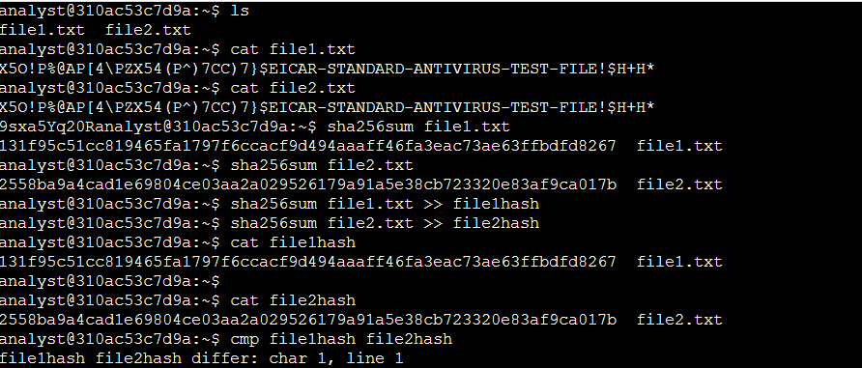 **Activity completed Using Linux bash shell**

**Explanation**

I used the ls command to check that both files were in the directory.

I then viewed the contents of both files using the cat command. The content appeared to be identical in both files.

To check if the files were truly identical, I calculated their hashes using the sha256sum command for each file. A hash function takes input and produces a fixed-size string of bytes. The output is unique to each different input: even a small change in the file will result in a completely different hash.

sha256sum file1.txt gave a hash of 131f95c51cc819465fa1797f6ccacf9d494aaaff46fa3eac73ae63ffbdfd8267.

sha256sum file2.txt resulted in a hash of 2558ba9a4cad1e69804ce03aa2a029526179a91a5e38cb723320e83af9ca017b.

I saved the hash of each file into new files named file1hash and file2hash using the sha256sum command redirected to write the hashes into these files.

To compare the hashes, I used the cmp command to check if there were any differences. The command cmp file1hash file2hash indicated that the hash files differed starting from the first character.

This confirmed that, despite appearing the same visually, the two files were not identical, as evidenced by their different hash values.